

Draw It or Lose It Web Game Application
CS 230 Project Software Design Template
Version 3.0
Prepared by: Alberto Rodriguez
Date: 06/21/2026

Table of Contents
Document Revision History
Executive Summary
Requirements
Design Constraints
System Architecture View
Domain Model
Evaluation
Recommendations

Document Revision History
Version | Date | Author | Comments
1.0 | 05/24/2026 | Alberto Rodriguez | Initial Project One software design document draft.
2.0 | 06/14/2026 | Alberto Rodriguez | Updated Evaluation section for Project Two platform analysis.
3.0 | 06/21/2026 | Alberto Rodriguez | Updated Recommendations section for Project Three systems architecture analysis.

Executive Summary
The Gaming Room currently has an Android-only game called Draw It or Lose It and wants to move it into a web-based version that can work across multiple platforms. The main design problem is making the game available to different users and devices while still keeping the game data organized, secure, and controlled. The proposed solution is to build the application around clear object-oriented classes, shared entity information, and a GameService class that controls game creation.
This design uses a singleton pattern so only one GameService instance exists in memory at a time. It also uses iterator-style searches to check existing games, teams, and players before creating new ones. This helps meet the client requirement that game and team names should be unique. For the final web version, the same model should be supported by a Linux server platform, a central database, secure network communication, and a browser-based client that can support desktop and mobile users.

Requirements
- The application must allow each game to include one or more teams.
- Each team must be able to include multiple players.
- Game and team names must be unique so users can check whether a name is already in use.
- The application must assign unique identifiers to games, teams, and players.
- Only one GameService instance should exist in memory at one time, which is handled through the singleton pattern.
- The future web version must support users connecting from multiple operating platforms through a browser or mobile device.

Design Constraints
A main design constraint is that the application is moving from an Android-only app to a web-based distributed environment. Because users may connect from different devices and operating systems, the design must avoid depending on one platform. The application should use a shared service layer and a structure that can be accessed by web clients, mobile devices, and desktop browsers.
Another constraint is data consistency. Since games, teams, and players can be created during play, the application must protect against duplicate names and duplicate identifiers. The GameService class helps with this by assigning IDs and checking existing objects before adding new ones. In a future web version, this same idea would need to be supported with a database and server-side validation so multiple users do not accidentally create conflicting game or team data at the same time.
Performance and reliability are also important constraints. The game uses timed rounds and clue rendering, so the system should respond quickly and avoid unnecessary delays. Network connectivity must also be considered because a web-based game depends on communication between the client device and the server. If a user loses connection, the design should be able to recover or keep the game state stable.
Security is another constraint because users may log in, join teams, and interact with game sessions. The system should protect user information, use secure communication, and control access to game data. These constraints affect development by requiring clear class responsibilities, strong validation, secure server-side logic, and a design that can grow beyond the first Java prototype.

System Architecture View
At this stage, the Java prototype focuses on the object model and service logic. A future production version would separate the system into a client layer, server application layer, database layer, and storage layer for game images. Browser and mobile clients would communicate with the server through secure APIs, while the server would manage game rules, timing, user sessions, and data persistence.

Domain Model
The UML class diagram shows the main classes used to organize the game application. Entity is the base class for the model because it stores the common id and name fields. Game, Team, and Player inherit from Entity, which shows inheritance and allows those classes to reuse shared attributes and behaviors instead of repeating the same code.
GameService manages the list of games and controls the next available IDs for games, teams, and players. This class is connected to the singleton pattern because the application should only have one GameService object in memory. GameService includes methods such as addGame(), getGame(), getGameCount(), and ID helper methods. These methods support the requirement that games must be created and found in an organized way.
The Game class contains a list of Team objects, and the Team class contains a list of Player objects. These relationships show aggregation because games are made up of teams, and teams are made up of players. The diagram also demonstrates encapsulation because class data such as IDs, names, games, teams, and players is managed through methods instead of being freely changed anywhere in the program.
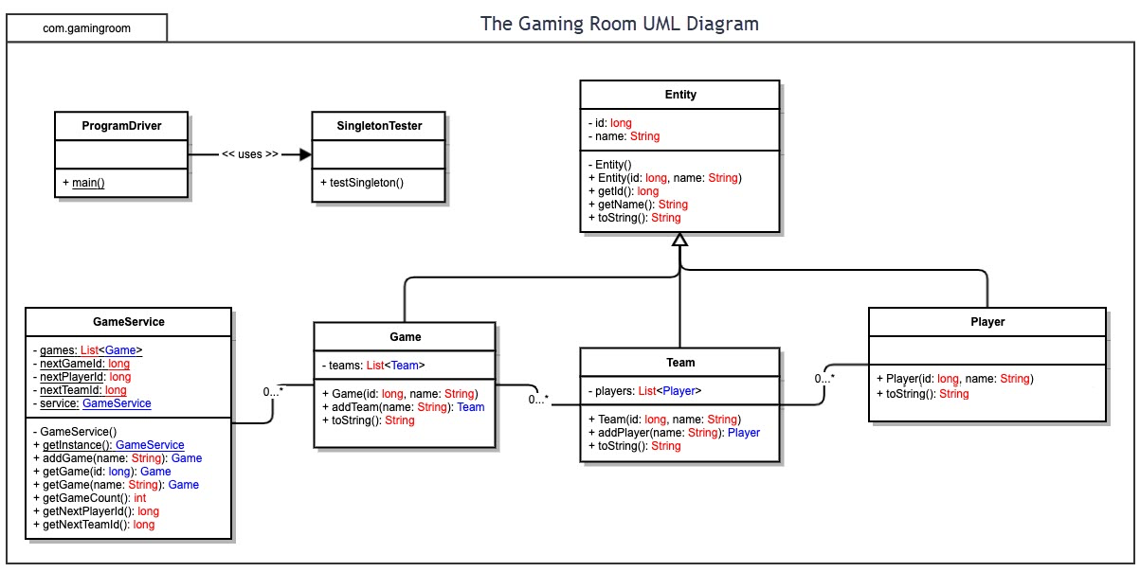
Figure 1. The Gaming Room UML class diagram.

Evaluation
The table below evaluates each platform at a high level for a web-based version of Draw It or Lose It. The focus is on server side needs, client side support, and development tools needed to move the game from Android-only to a browser-based application.
Development Requirements | Mac | Linux | Windows | Mobile Devices
Server Side | macOS can run development tools and some server software, but it is not the best production hosting option for this game. It is less common for large web server deployment and usually depends on Apple hardware, which can raise cost. Its strongest use is development and testing for Safari and Apple device compatibility. | Linux is the strongest server choice for this project. It supports common web server software such as Apache or Nginx, Java application servers, databases, REST services, and cloud hosting. It is stable, secure, cost-effective, and widely used for scalable web applications. | Windows Server can host the web application using IIS, Java or .NET services, databases, and cloud tools. It is a good option for organizations that rely on Microsoft products, but licensing costs and system overhead may be higher than Linux. | Mobile devices should not host the server side. Android and iOS devices should be treated as client devices because they have smaller screens, battery limits, limited resources, and changing network connections.
Client Side | Mac users can access the game through Safari, Chrome, Firefox, or Edge. Testing on macOS is important because Safari can behave differently with timers, image rendering, animations, and layout. | Linux desktop users can play through a modern browser such as Chrome, Firefox, or Edge. No separate Linux desktop app is needed if the application follows web standards and uses a responsive browser interface. | Windows has a large desktop user base, so browser testing on Windows is important. Players can access the game through Chrome, Edge, Firefox, or other modern browsers. Testing should include mouse, keyboard, touchscreen behavior, and screen sizes. | Mobile clients must use responsive HTML, CSS, and JavaScript so the game works on phones and tablets. The design must support touch controls, portrait and landscape views, smaller screens, and different device resolutions.
Development Tools | Useful tools include Java, HTML, CSS, JavaScript, REST APIs, Git, Eclipse, IntelliJ IDEA, Visual Studio Code, browser testing tools, and Xcode. A Mac is needed for full Safari and iOS testing. | Useful tools include Java, HTML, CSS, JavaScript, REST APIs, Git, Eclipse, IntelliJ IDEA, Visual Studio Code, database tools, and server deployment tools. Linux closely matches many production server environments. | Useful tools include Java, HTML, CSS, JavaScript, REST APIs, SQL tools, Eclipse, IntelliJ IDEA, Visual Studio Code, Microsoft Visual Studio, and PowerShell. Some Microsoft server tools may require licenses. | Useful tools include Android Studio, Xcode, Chrome DevTools, Safari Web Inspector, responsive design testing tools, JavaScript, HTML, CSS, REST APIs, emulators, and real devices for testing.
Project Two Platform Summary: Linux is the recommended server operating platform because it is reliable, scalable, and cost-effective for a web-based game. Windows Server is a possible alternative if The Gaming Room wants to stay in a Microsoft environment, but licensing may increase cost. macOS should mainly be used for development and testing rather than production hosting. For the client side, the best approach is a responsive browser-based application that works on Windows, macOS, Linux, Android, and iOS without requiring separate full applications for each platform.

Recommendations

Operating Platform
Linux is the recommended operating platform for the server side of Draw It or Lose It. Linux is a strong choice because it is stable, secure, cost-effective, and commonly used for web servers and cloud-based applications. Since The Gaming Room wants to expand the game beyond Android and make it available across multiple operating systems, the main game logic, user accounts, image library, and game data should stay on the server. Users on Windows, macOS, Linux, Android, iOS, or a web browser can then connect to the same system through the internet.

Operating Systems Architectures
The recommended platform would use a Linux server architecture. Linux uses a layered architecture that separates user applications from the operating system kernel. The kernel is the core part of the operating system and manages the CPU, memory, storage, networking, and system resources. Above the kernel are system libraries, services, and user applications. For Draw It or Lose It, the game application would run as a server-side application on Linux. The server would handle user logins, game sessions, team information, clue image delivery, timing, and communication between players. Client devices would not need to manage the full game logic. Instead, they would send requests to the server and receive responses. This architecture supports multitasking, multiuser access, networking, and strong permission controls.

Storage Management
For storage management, the application should use a relational database management system such as PostgreSQL or MySQL along with server file storage or cloud object storage for the game image library. The database should store structured data such as users, teams, games, rounds, scores, and session information. The clue image files should be stored separately in a file storage system or cloud storage service, while the database stores references to those files. This separation is useful because game records and image files have different storage needs. User and game information must be searched, updated, protected, and backed up carefully. Image files need to be stored efficiently and delivered quickly to users. Linux also supports reliable file systems such as ext4 or XFS, which help organize data, manage permissions, and support dependable storage.

Memory Management
Linux uses memory management techniques such as virtual memory, paging, process isolation, and memory allocation. Virtual memory allows each running process to act like it has its own memory space. This helps protect the server application because one process cannot easily access or damage another process memory. Paging allows Linux to move memory data between RAM and disk when needed, which helps the system continue running when memory demand increases. For Draw It or Lose It, memory management is important because the server may need to manage many active games, users, timers, and image requests at the same time. The Java runtime would also use automatic garbage collection to remove unused game objects. The application should be designed to end old sessions properly and avoid memory leaks after a game round or session ends.

Distributed Systems and Networks
Draw It or Lose It should use a distributed system design so players on different devices and operating systems can communicate with the same central server. In this model, the server holds the main game logic and data, while client devices connect through the internet. Communication can be handled through REST APIs for standard requests such as logging in, joining a game, and retrieving game data. For real-time gameplay features such as timers, guesses, and game updates, WebSockets could be used so the server and clients can communicate quickly during a live game session. The design should also plan for slow connections, temporary outages, and disconnected users. The server should manage the official game state so that if a client disconnects and reconnects, it can receive the current game information again.

Security
Security should be built into the system from the start because the application may store user accounts, login information, and game history. The Linux server should use strong user permissions, firewall rules, regular security updates, and secure configuration settings. Only authorized administrators should have access to server files and database systems. User passwords should never be stored as plain text. They should be hashed and salted before being saved in the database. Communication between client devices and the server should use HTTPS/TLS encryption so usernames, passwords, and game data are protected while traveling across the network. The system should also use authentication and authorization so users only access the actions and game sessions they are allowed to use. Other protections should include input validation, database access controls, logging, and regular backups.

Overall Recommendation
Overall, The Gaming Room should use a Linux-based server platform with a client-server and distributed system design. This gives the company a stable, secure, and scalable way to expand Draw It or Lose It to multiple operating systems. The game logic and data should stay on the server, while users connect through platform-specific browsers or mobile devices. This approach makes the system easier to maintain, improves security, and allows the game to grow across different computing environments.

